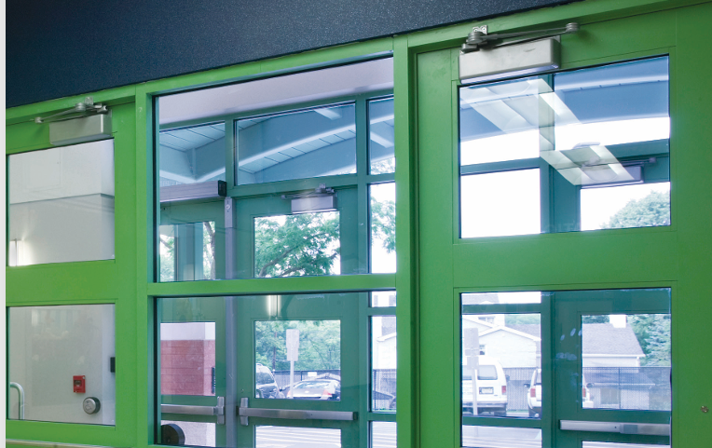

LCN AUTO OPERATOR TRAINING
TUESDAY, OCTOBER 21ST
8:00 AM – NOON

EWERT HARDWARE
5801 W 117TH PLACE, ALSIP, IL

PLEASE RESERVE A SEAT IN ADVANCE THROUGH YOUR EWERT INC. SALES REP

